

EMPLOYEE LEAVE AND PAYROLL MANAGAMENT SYSTEM – DELIVERABLE 1

Course: Software Engineering
Instructor: Ms. Rabail Zahid

Submission Date: 28th February 2025

BY:
The Scytes
Ruhab Ahmad (23I-0559)
Hasan Altaf (23I-0698)
Muhammad Saqib (23I-0769)

Team Name
The Scytes

Team Logo
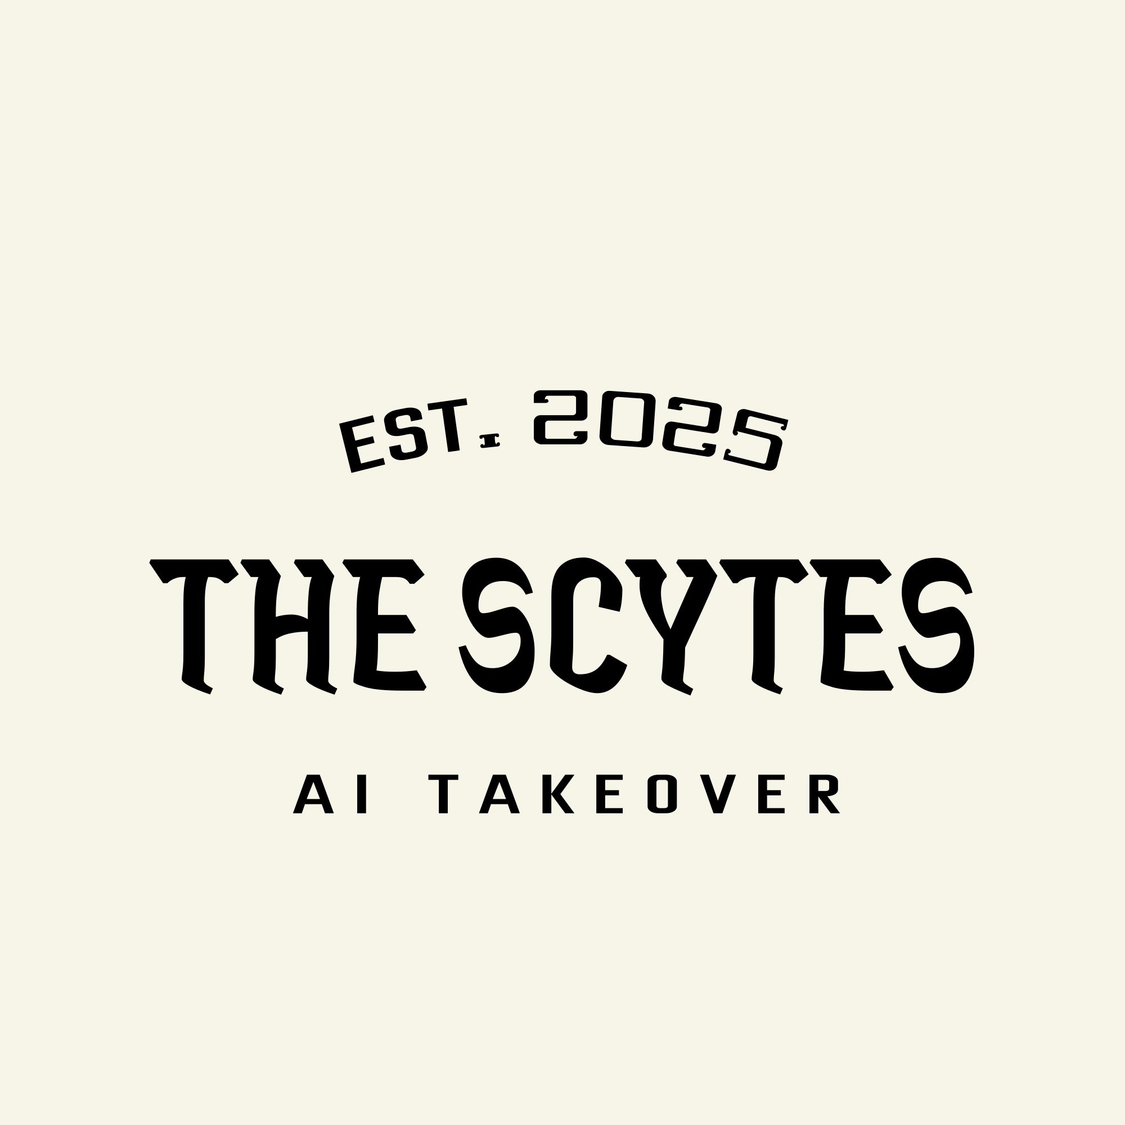

Group Picture

Team Lead
Hasan Altaf (23i-0698)

Team Members

Hasan Altaf - Scrum Master & Team Lead
Hasan Altaf - GitHub

I am Muhammad Hasan Altaf, a BSCS student from Batch 2023 at FAST NUCES Islamabad, currently in my sixth semester. I am passionate about programming, problem-solving, and building real-world software projects. I continuously work on improving my skills in web development, AI, and data structures to grow as a professional developer.

Muhammad Saqib - Developer
Saqib - GitHub

I am Muhammad Saqib Atif, a BSCS student from Batch '23 at FAST NUCES Isb. A passionate developer, I aim at improving my skills in web development, AI engineering, and software development to grow as a versatile computer scientist

Ruhab Ahmad - Developer
Ruhab - GitHub

I am Ruhab Ahmad, a junior-year Computer Science student at FAST–NUCES, Islamabad. I am a curious and detail-oriented person who is always eager to learn new things. My expertise lies in C++, Python, and full-stack development.

Assigned Roles
Member | Role
Hasan Altaf | Scrum Master, Team Lead
Ruhab Ahmad | Backend Developer
M. Saqib | Backend Developer
All Members | Testers
Ruhab Ahmad | Requirement Analyst
M. Saqib | UI Designer

Team Agreement
Communication Methods
- WhatsApp group for daily communication
- Google Meet for meetings
- Trello for formal submission discussions
Response Time
- WhatsApp: within 2 hours
- Email: within 24 hours
- Urgent matters: phone call
Meetings
- Twice weekly
- All meetings mandatory
- Online meetings via Google Meet
Running Meetings
- Led by Scrum Master
- Minutes recorded by rotating member
- Agenda shared before meeting
Meeting Preparation
- Members review assigned tasks
- Prepare progress updates
Version Control
- GitHub repository
- Commit only working code
- Clear commit messages
- No direct changes to main branch
Division of Work
- Tasks assigned by Team Lead
- Based on skill and availability
- Stakeholders: HR staff, employees, management
Submission Process
- Reviewed by all members
- Submitted by Team Lead
- Submitted one day before deadline
Contingency Planning
- Missed work reassigned
- Repeated absence reported
- Academic dishonesty → removal from project

